High Level Process / User Stories

- Validate Spreadsheet/Data Table is correct (one column of VAT numbers and one column of company names with at least one entry).

- Split into batches and invoke tasks

- Validate VAT numbers

- Update spreadsheet (if invalid or exception occurs)

- Email stakeholders/Error Handling

Expected volume: 8000 vat numbers per week, once per week

Current time to complete as is process: 2 – 3 hours

Estimated time to complete automation: 30 – 60 minutes depending on response times

Platforms used
(​https://ec.europa.eu/taxation_customs/vies/​) – SOAP API Available

Example of post request:
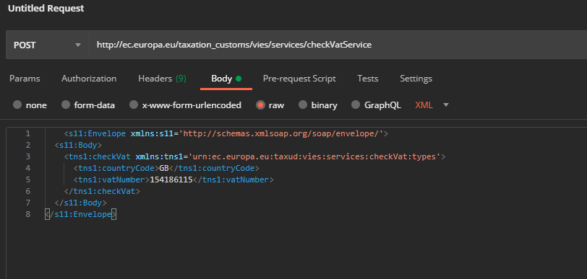
Example of xml response:

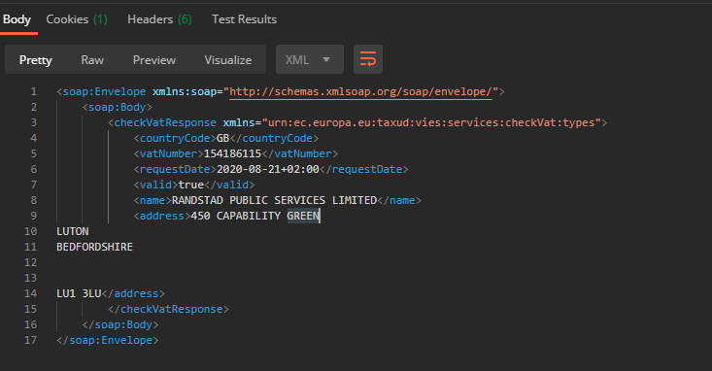
typical response time is 200 – 500ms per post request

Notes:

- Better to pass data in batches as XML in invocation? How would the results be compiled
- Is a separate invoker required which takes batches from spreadsheet and creates XML?
- Keep VIES user story as loosely coupled as possible in case UK VAT numbers are validated differently in future

- Manual check in VIES website as error handling could be introduced as enhancement if time
- There are times where the VIES database is responding slowly, thus requiring more time to return a response. This should be considered while designing the automation

Test Data:
VAT Number Company Name
492 4357 26 Randstad UK
154186115 Randstad Public Services
535-5640-42 Randstad Select

Assumptions:

1. Since the spreadsheet does not have a country column, country will always be “GB-United Kingdom”
2. Entry to Payroll System will be implemented as a second phase, VAT check is minimum viable product for phase one delivery.
3. Invalid numbers will be manually queried, so business exceptions ie. numbers that cannot be validated (for example EU companies that have somehow made it into the spreadsheet) can also be handled in this way (in other words, risks can be mitigated by marking as invalid sending work to the manual queue, even if VIES has not explicitly stated they are invalid).

Risks/Mitigation:

Valid VAT numbers marked as invalid due to errors/exceptions – Will be worked manually
Spreadsheet is not provided – Notify correct department by email
Window to run is within 2-3 hours of dependant process – based on est runtime there is time for one retry, but relevant department should be notified of failure if possible.

